Nextgen NIC Changes for Thurs, 9/30/21

Put SCOM in Maint mode

Cluster Mgr, Nodes, Network tab at bottom, change ip of cluster and remove the heartbeat. Bounce after the heartbeat nic is removed. Make 412 primary again. Note 9/30: both sides of cluster went into recovery/not synching status after the 312 node nic change and reboot. Continue on to Cluster Mgr, change the Win cluster ip and then the SQL Listener AO ip. Once you bring these two online, the databases should change status back to synchronized. Another note, make sure Network team “reserves in DNS” the ip address. This was noticed when could not failover to 312 node successfully, and then tried to ping new 412 server from multiple servers, and still had old ip, even after “ipconfig /flushdns”.

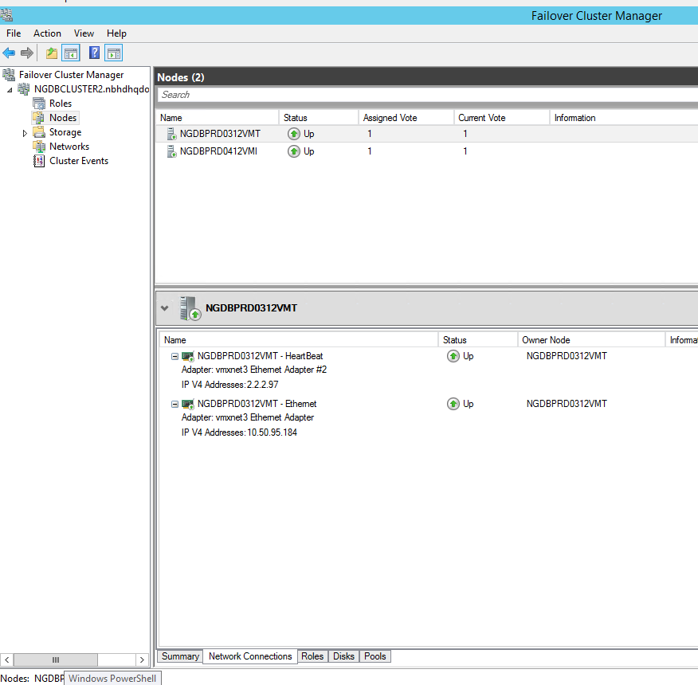

Roles, Resources tab and change/cleanup Win Cluster ip

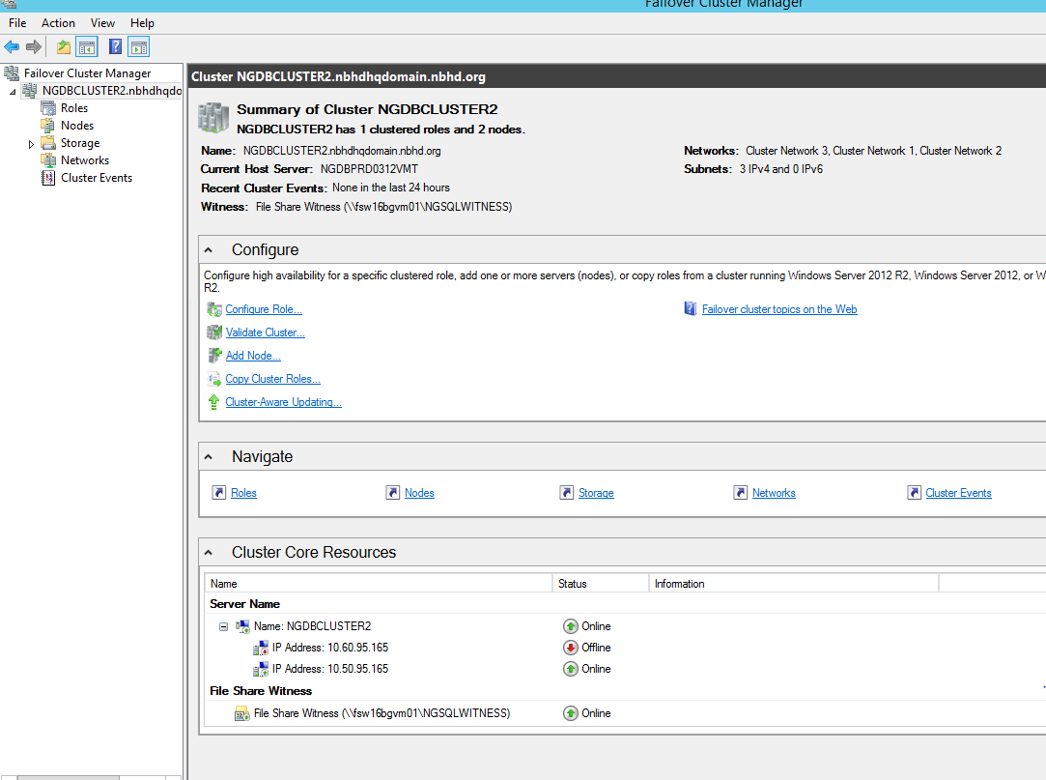

Need to add the new ip address in properties below, and cleanup/delete the old ones.

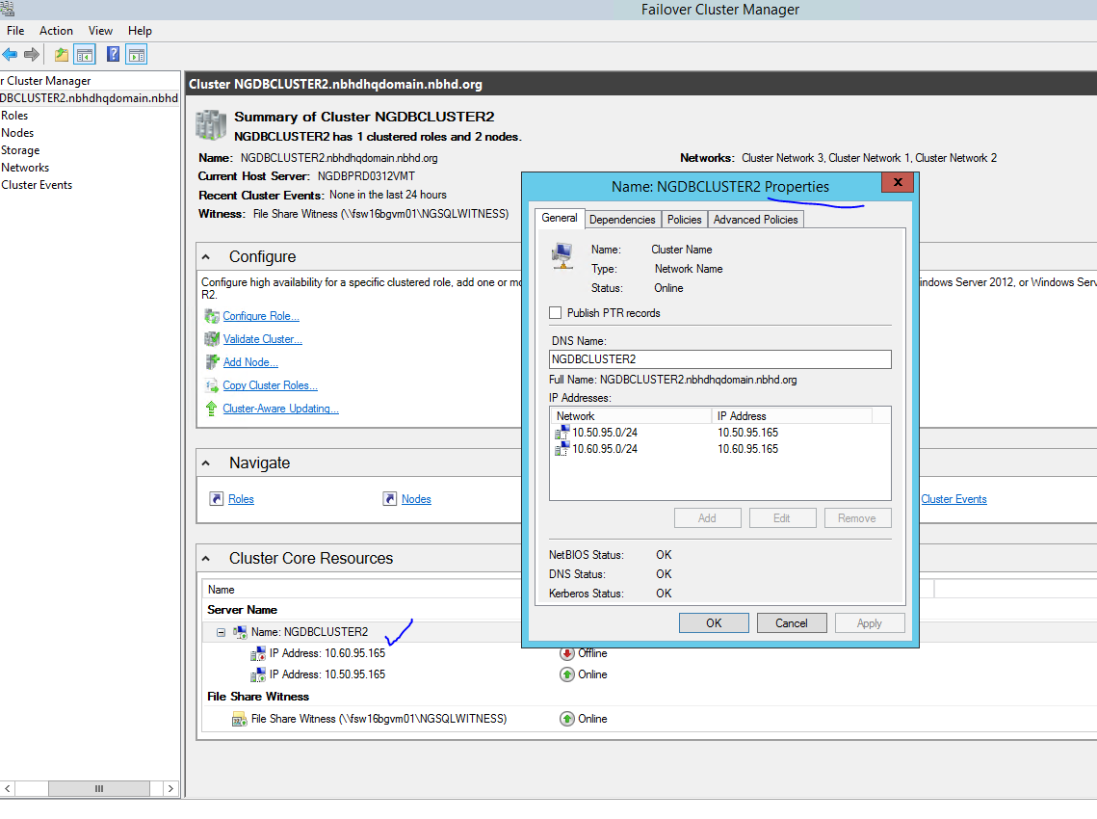

For changing the AO listener. Need to add the new ip address in properties below, and cleanup/delete the old ones.

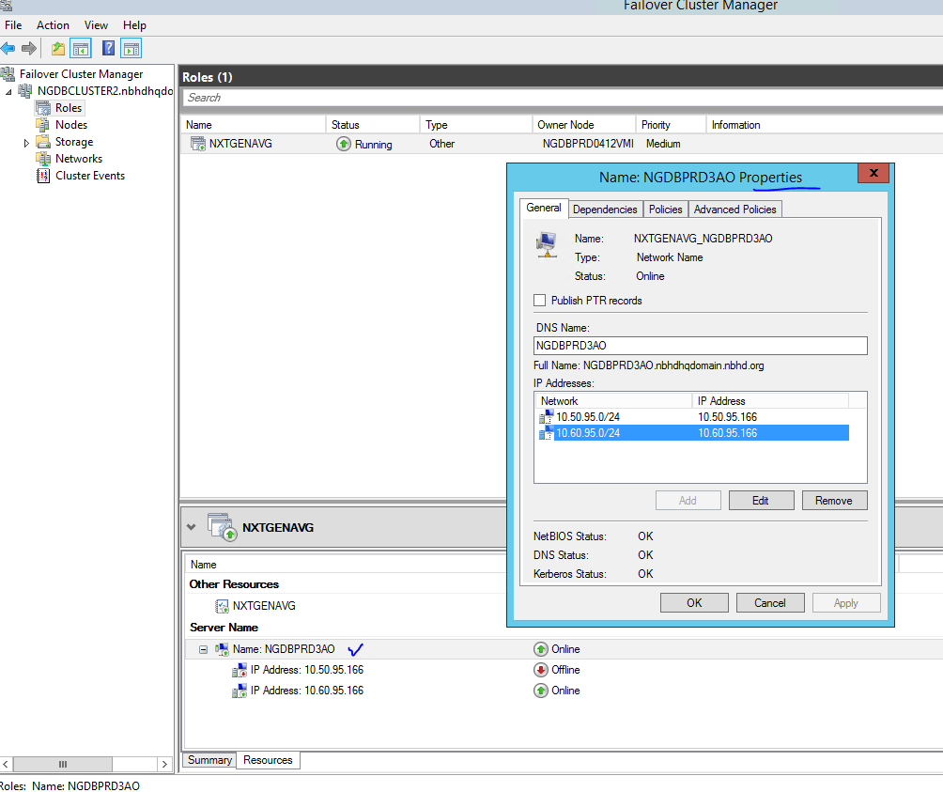

Make sure primary is 412 and start SSMS and verify all is working correctly. 😊

\*\*\* After the IP switchover, the BBP services will need to be restarted on the BBP server(s): NGBBP0212DCVM and NGBBP0312DCVM so that the automated scheduled BBP jobs initiate and run.

Regards, Phill Baker

Turn off SCOM maint mode for NG servers

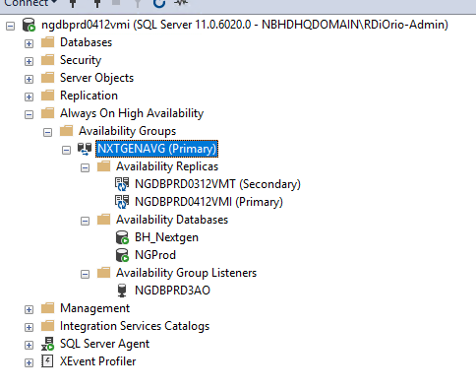

Before NIC changes 9/29/21

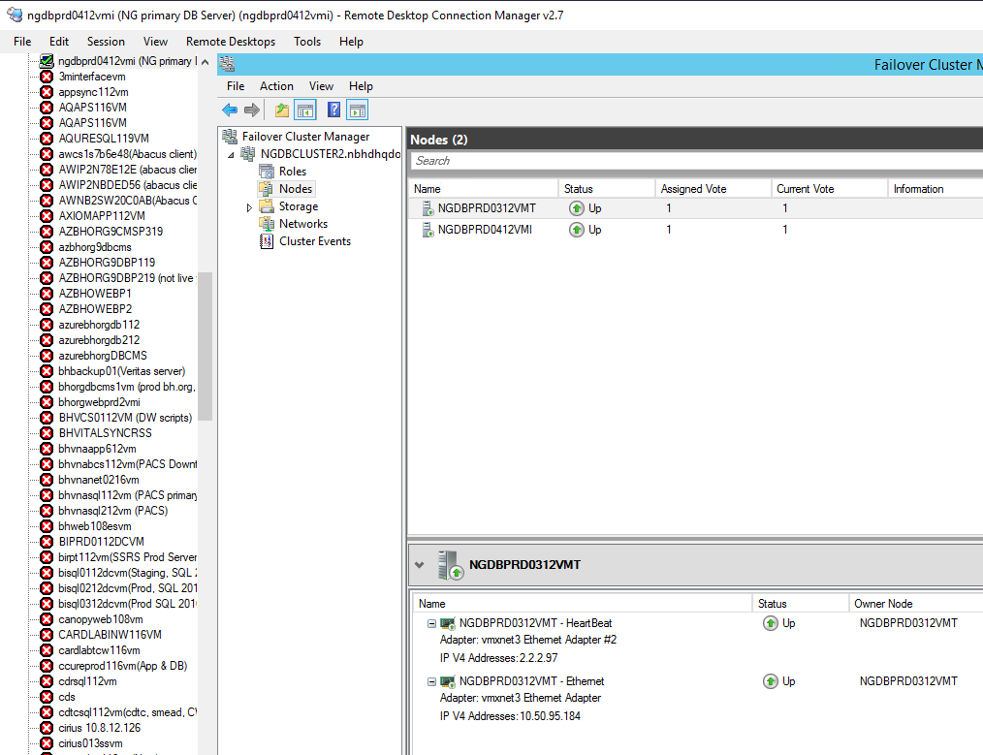

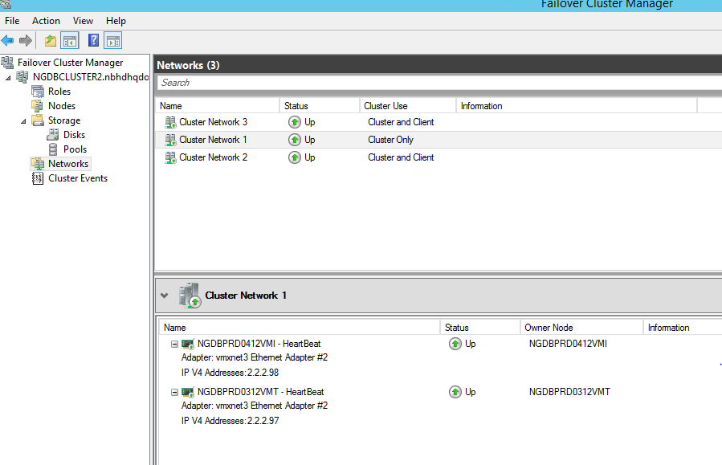

Cluster Network 1 = heartbeat for each node, Cluster netwrk 2 = ngdbprd0312vmt, cluster netwk 3=ngdbprd0412vmi